Principio del formulario
EXAMEN DEL MODULO 9 (con 66.7%)
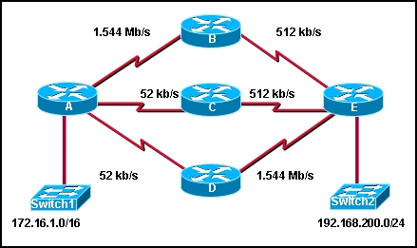
Refer to the exhibit. All interfaces have been configured with the bandwidths that are shown in the exhibit. Assuming that all routers are using a default configuration of EIGRP as their routing protocol, what path will packets take from the 172.16.1.0/16 network to the 192.168.200.0/24 network?
 | A,B,E
 | A,C,E
 | A,D,E
 | Packets will load balance across the A,B,E and A,C,E paths.
 | Packets will load balance across the A,B,E and A,D,E paths.
 | Packets will load balance across the A,C,E and A,D,E paths.

2 | Principio del formulario
  Which two statements describe characteristics of EIGRP? (Choose two.)
   | EIGRP is a distance vector routing protocol.
   | EIGRP supports classless routing and VLSM.
   | EIGRP is classified as a link-state routing protocol.
   | EIGRP uses TCP for reliable delivery of EIGRP update packets.
   | With EIGRP, loop-free paths are achieved through the use of hold-down timers.
   | EIGRP sends a periodic update every 30 minutes.

3 | Principio del formulario
  The show ip eigrp topology command output on a router displays a successor route and a feasible successor route to network 192.168.1.0/24. In order to reduce processor utilization, what does EIGRP do when the primary route to this network fails?
  The router sends query packets to all EIGRP neighbors for a better route to network 192.168.1.0/24.
  The DUAL FSM immediately recomputes the algorithm to calculate the next backup route.
  Packets that are destined for network 192.168.1.0/24 are sent out the default gateway instead.
  The backup route to network 192.168.1.0/24 is installed in the routing table.
4 | Principio del formulario
  On a router running EIGRP, what database would maintain a list of feasible successors?
  routing table
  neighbor table
  topology table
  adjacency table

5 | Principio del formulario
  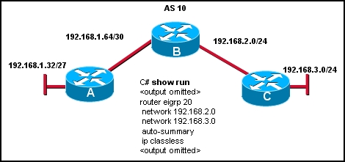
  Refer to the exhibit. The company is using EIGRP with an autonomous system number of 10. Pings between hosts on networks that are connected to router A and those that are connected to router B are successful. However, users on the 192.168.3.0 network are unable to reach users on the 192.168.1.32 network. What is the most likely cause of this problem?
  IP classless is enabled and is causing the packet to drop.
  The command network 192.168.1.32 was not issued on router C.
  The routers are not configured in the same EIGRP routing domain.
  Automatic summarization of the networks is causing the subnetted routes to be dropped.
Principio del formulario
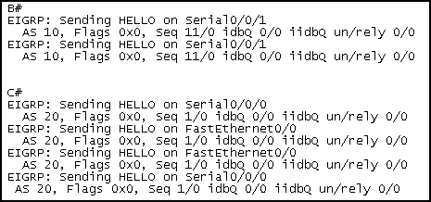
Refer to the exhibit. This is the debug output from 2 directly connected EIGRP routers. They are not forming an adjacency. What is the cause?
one router is a non-cisco router
they have different autonomous-system numbers
they are using difference sequence numbers
they are sending incorrect hello types

7 | Principio del formulario
  What information is maintained in the EIGRP topology database for a destination route? (Choose three.)
  the routing protocol
  the feasible distance of the route
  the highest cost of the route
  the SRTT value for the route
  the route cost as advertised by the neighboring router
  the physical address of the gateway interface

8 | Principio del formulario
  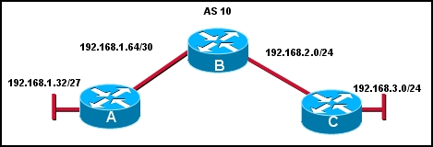
  Refer to the exhibit. Which command will advertise the 192.168.1.64/30 network but not the 192.168.1.32 network on router A?
  network 192.168.1.0
  network 192.168.1.0 255.255.255.0
  network 192.168.1.64 0.0.0.3
  network 192.168.1.64 0.0.0.7
  network 192.168.1.64 0.0.0.255
9 | Principio del formulario
  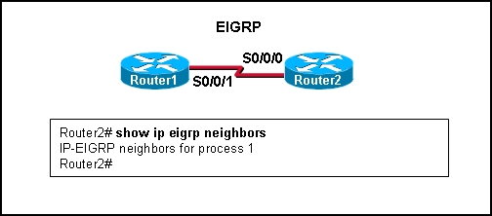
  Refer to the exhibit. Based on the output of show ip eigrp neighbors, what are two possible problems with adjacencies between Router1 and Router2? (Choose two.)
  The routers are configured with different EIGRP process IDs.
  Automatic summarization was disabled.
  The hello timer for R1 was altered.
  The serial interfaces for both routers are in different networks.
  No feasible successors were found.

10 | Principio del formulario
  Which term defines a collection of networks under the administrative control of a single entity that presents a common routing policy to the Internet?
  autonomous system
  contiguous networks
  process ID
  BGP
11 | Principio del formulario
  Which of the following types of routes will be denoted by EX in EIGRP routing table entries? (Choose two.)
  routes learned from other routing protocols
  routes learned from any non-adjacent EIGRP routers
  any route with a hop count metric higher than 224
  EIGRP routes that originate in different autonomous systems
  all passive routes in the routing table
12 | Principio del formulario
  In which of the following tables does the EIGRP DUAL algorithm store the primary route to a destination? (Choose two.)
  routing
  topology
  neighbor
  path
  shortest path

13 | Principio del formulario
  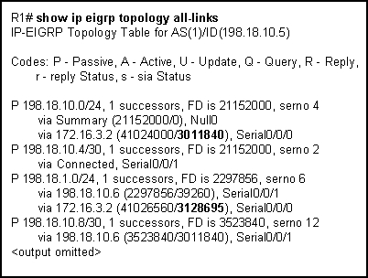
  Refer to the exhibit. In the topology table, what do the numbers 3011840 and 3128695 represent?
  the route metric that is applied to those EIGRP routes for this router
  the trustworthiness of the routing information source
  the composite of the hop count and bandwidth to that destination network
  the total metric for that network as advertised by the EIGRP neighbor
14 | Principio del formulario
  By default, which two metrics are used by EIGRP to determine the best path between networks?
  MTU
  load
  delay
  bandwidth
  reliability

15 | Principio del formulario
  What two actions will the EIGRP DUAL FSM take if a link to a network goes down? (Choose two.)
  put the route into passive mode
  query neighbors for a new route
  search routing table for a feasible successor
  run the SPF algorithm to find a new successor
  search topology table for a feasible successor
Principio del formulario
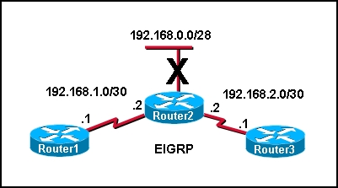
Refer to the exhibit. Network 192.168.0.0/28 goes down. What type of packet does Router2 immediately send to Router1 and Router3?
a query for network 192.168.0.0/28
an acknowledgment packet to 224.0.0.9
an update packet that is sent to 255.255.255.255
a packet that contains the new routing table for R2
unicast update packets to 192.168.1.1 and 192.168.2.1

17 | Principio del formulario
  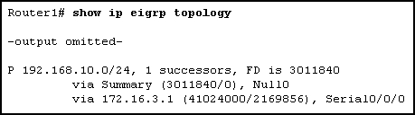
  Refer to the exhibit. What is indicated by the P at the beginning of the topology entry?
  the route is in a stable state
  the route is a preferred route
  DUAL is searching for a better route to this destination
  the exit interface is in passive mode and EIGRP advertisements are blocked

18 | Principio del formulario
  In the command router eigrp 20, what is the purpose of the number 20?
  specifies the administrative distance for all EIGRP routes
  identifies the autonomous system number this EIGRP process will advertise
  determines what metric is added to all advertised routes
  indicates the number of addresses in the EIGRP routing domain
19 | Principio del formulario
  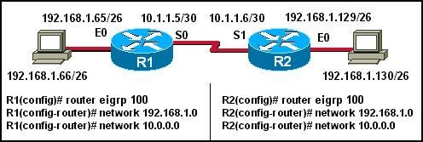
  Host 192.168.1.66 in the network illustrated is unable to ping host 192.168.1.130. How must EIGRP be configured to enable connectivity between the two hosts? (Choose two.)
  R1(config-router)# network 192.168.1.128
  R1(config-router)# auto-summary
  R1(config-router)# no auto-summary
  R2(config-router)# no auto-summary
  R2(config-router)# auto-summary
  R2(config-router)# network 192.168.1.64

20 | Principio del formulario
  Which of the following statements describes the bounded updates used by EIGRP?
  Bounded updates are sent to all routers within an autonomous system.
  Partial updates are sent only to routers that need the information.
  The updates are sent to all routers in the routing table.
  Updates are bounded by the routers in the topology table.
Principio del formulario
What administrative distance would a router assign to a default route in EIGRP that is learned from a source external to the autonomous system?
1
5
70
90
170
190

22 | Principio del formulario
  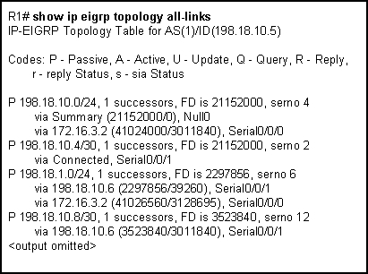
  Refer to the exhibit. EIGRP is the only routing protocol enabled on this network. No static routes are configured on this router. What can be concluded about network 198.18.1.0/24 from the exhibited output?
  A route to network 198.18.1.0/24 is not listed in the routing table.
  Packets that are destined for 198.18.1.0/24 will be forwarded to 198.18.10.6.
  EIGRP will perform equal cost load balancing across two paths when forwarding packets to 198.18.1.0/24.
  The router with interface 172.16.3.2 is a successor for network 198.18.1.0/24.

